SX5d and SX5e GPRS PROCEDURE

SCOPE: TO BROWSE THE INTERNET USING A WIRELESS TERMINAL.

EQUIPMENT:

1) Computer.
2) SX5d Deskphone or SX5E FWT.
3) RS-232 Cable (DB9-DB9).
4) Power Supply (7.1VDC).
5) Network Provider Configuration.
6) HyperTerminal (ver. 5) SOFTWARE
7) Dial-up Networking SOFTWARE

PROCEDURE:

- CONNECT THE COMPUTER TO THE SX5 WITH THE RS-232C CABLE.
TURN-ON POWER TO BOTH, COMPUTER AND SX5. (Illustration 1).

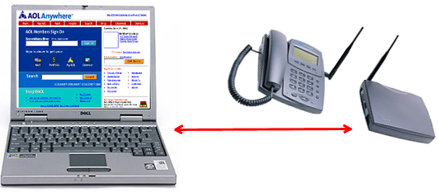
Ill. 1.

2) From the PC Start Menu select ‘Settings’, then click on ‘Control Panel’.
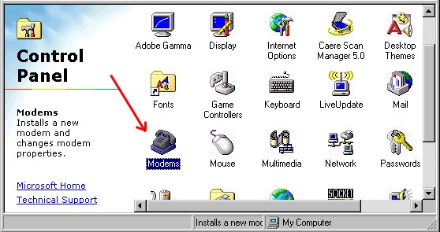
On the ‘Control Panel’ GUI double click on ‘Modems’. (Fig. 1)

Fig. 1.

3) Select ‘Standard 19200 bps Modem’ and click on ‘Properties’ (Fig. 2).
Select ‘Communication Port (COM 1)’ and ‘Maximum speed 115200’; Click
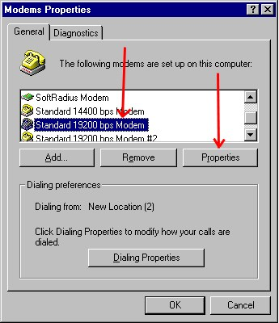
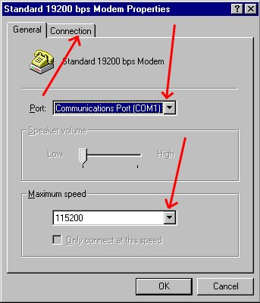
on ‘Connection’. (Fig. 3)

Fig. 2 Fig. 3

4) Set ‘Connection preferences’ as per “Fig. 4” and click on ‘Advanced’. (Fig. 4).
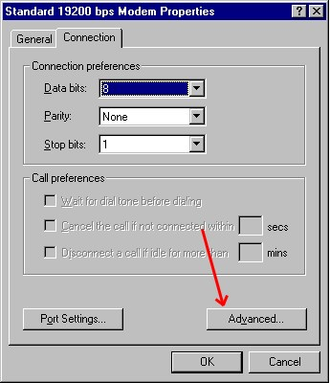
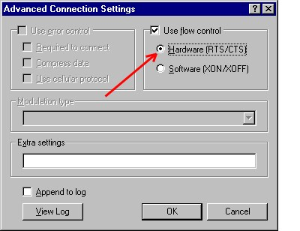
Check ‘Use flow control’, click on ‘Hardware (RTS/CTS)’ & click on ‘OK’. (Fig. 5).

Fig. 4. Fig. 5.

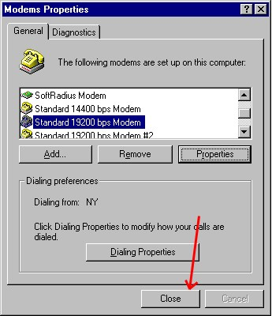
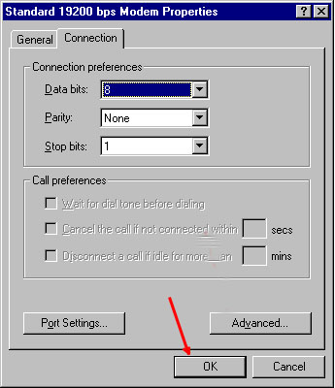5) Click on ‘OK’ (Fig. 6). Click on ‘Close’ (Fig. 7).

FIG. 6. Fig. 7.

6) Start a new HyperTerminal connection.
Type ‘Telular GPRS’ in the “Name” entry field, chose an ‘Icon’ and click on ‘OK’.
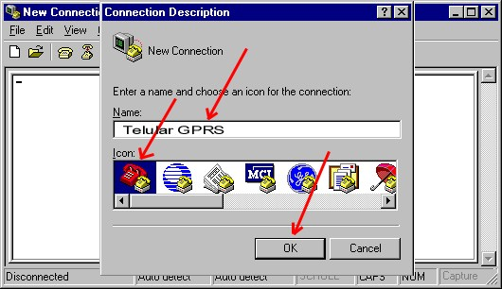
(Fig. 8).

Fig. 8

7) Select ‘Direct to Com 1’ and click on ‘OK’. (Fig. 9).

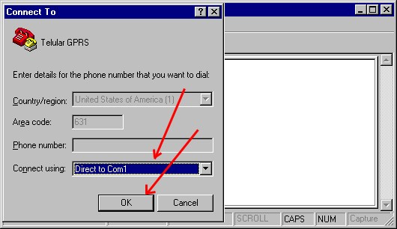
Fig. 9

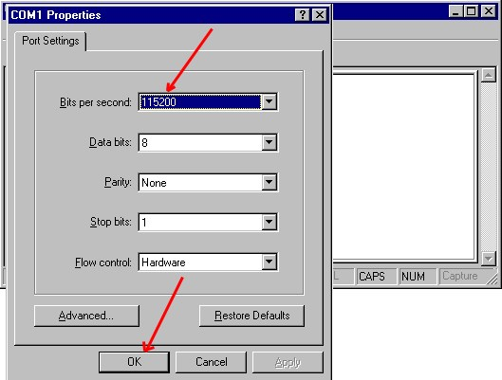
8) On ‘Bits per second:’ select ‘115200’, then click on ‘OK’. (Fig. 10).

Fig. 10

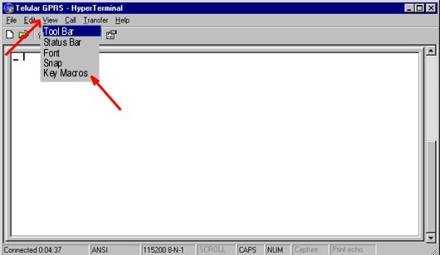
9) Click on ‘View’, select and click on ‘Key Macros’. (Fig. 11).

Fig. 11

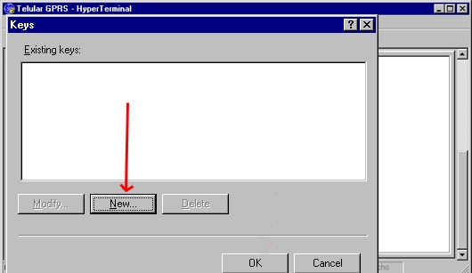
10) Click on ‘New’. (Fig. 12).

Fig. 12

- Left click on the entry field ‘Key:’ and on the computer keyboard hit the keys “Ctrl” & “G” sequentially. Left click on the entry field ‘Action’ and on the computer keyboard type: AT+CGDCONT=1,”IP”,”internet3.voicestream.com”
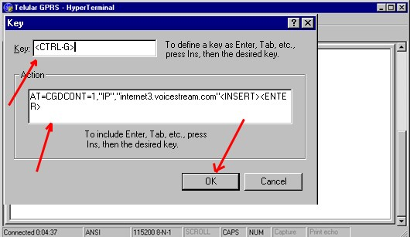
(On the keyboard press the “Insert” key two times and the “Enter” key once.
Exit the GUI by clicking on ‘OK’. (Fig. 13).

Fig. 13

- Click on ‘OK’. (Fig. 14).
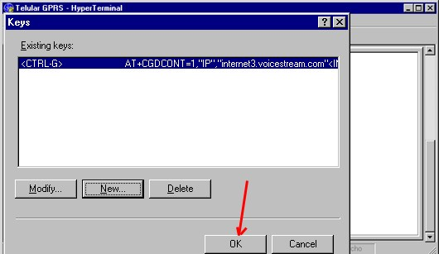
Fig. 14

- On the HyperTerminal window click on ‘File’ and select “Save As…”.
Save the HyperTerminal Connection. (Fig. 15).
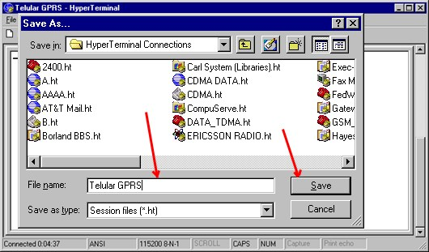
Fig. 15

15) On ‘HyperTerminal Connections’ double click on the “Telular GPRS’ icon.
Once the GUI is on the PC screen, execute the “Ctrl” & “C” macro.
(This command causes the setting of the Access Point Name in the SX5.)
Hang-up the connection and exit HyperTerminal. (Fig. 16).
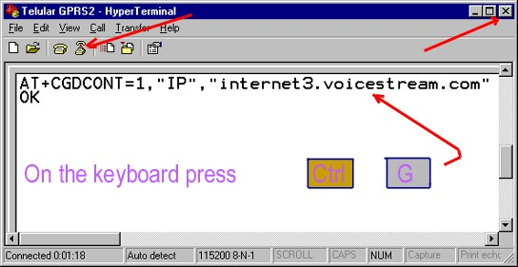
Fig. 16

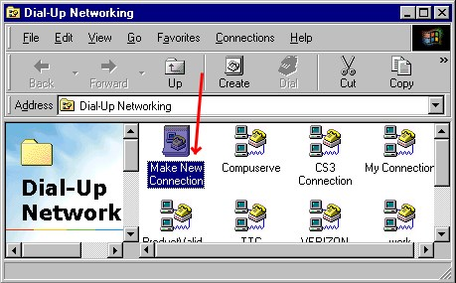
16) Run ‘Dial-up Networking’. Double click on the icon ‘Make New Connection’. (Fig. 17).

Fig. 17

17) Type Telular GPRS on the first entry field; select the ‘Standard 19200 modem’
and click on ‘Next’. (Fig. 18). Type the Network Provider’s phone number (*99#)
and click on ‘Next’. (Fig. 19)
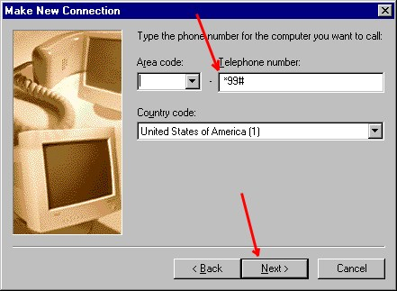
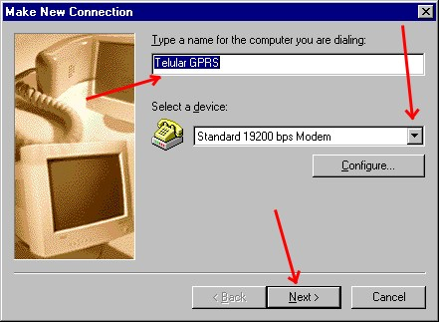
Fig. 18 Fig. 19

18) Click on ‘Finish’. (Fig. 20). Right click on the icon ‘Telular GPRS’ and left click on
‘Properties’. (Fig.21).
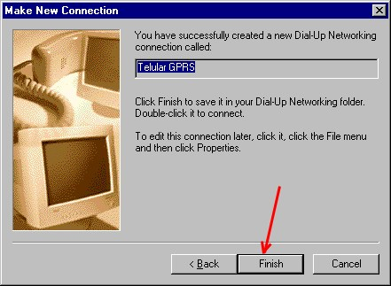
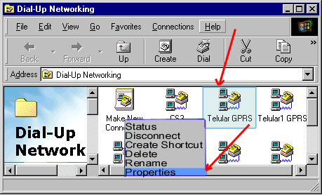

Fig20 Fig. 21

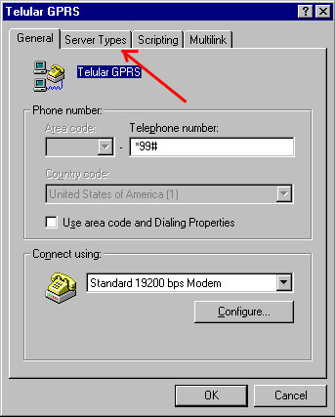
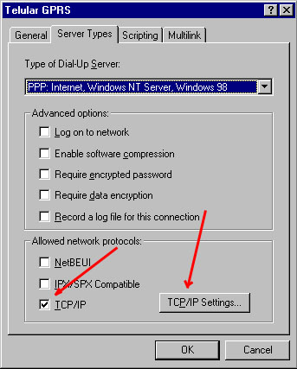
19) {Do not check ‘Use area code and Dialing Properties’.} Click on ‘Server Types’.
(Fig. 22). Check ‘TCP/IP’ and click on ‘TCP/IP Settings…’. (Fig. 23).

Fig. 22 Fig. 23

20) Select both ‘Server assigned…’, then check both ‘Use IP header compression’ &
‘Use default gateway….’ and click on ‘OK’. (Fig. 24). Click on ‘OK’ on the
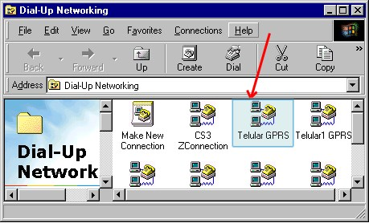
subsequent GUI. Ex. Fig.22. Double click on the Telular GPRS icon. (Fig. 25).
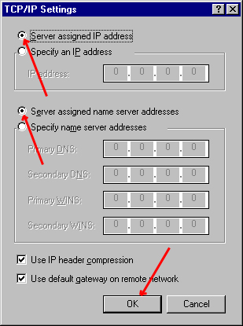
Fig. 24 Fig. 25

21) Type “iStream” on the ‘User name entry field’, then type (dummy) on the
‘Password’ entry field and click on “Connect’. (Fig. 26).
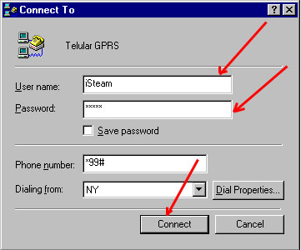

Fig. 26

22) Observe that the Internet connection is in progress. (Fig. 27).
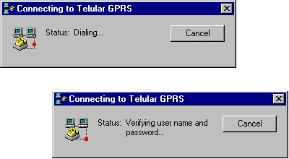
Fig. 27

23) The yellow arrow points to the icon that indicates a successful Internet
connection. Start browsing the Internet by double clicking the icon indicated
by the red arrow. (Fig. 28).

Fig. 28

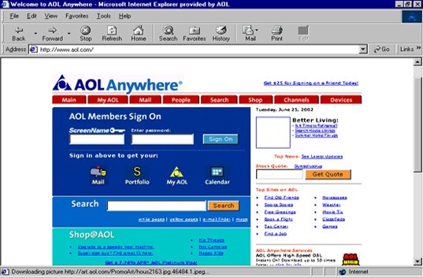
24) Select ‘File Exit’ to exit browsing the Internet. (Fig. 29).

Fig. 29

25) Double click on the ‘Internet connection’ icon {yellow arrow}. (Fig. 28.).
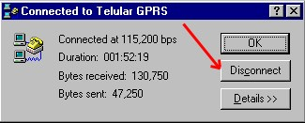
Click on ‘Disconnect’ to interrupt the Internet connection. (Fig. 30).
Fig. 30

Notes:
1) On page 6-paragraph 11-line 4 write 2 instead of 3, if required.

- Double click the ‘Mail’ icon on “figure 29”.


One may hear from the SX5d speaker:

YOU’VE
GOT
MAIL!

